Steps for build VPC

1. create VPC subnet 10.0.0.0/16

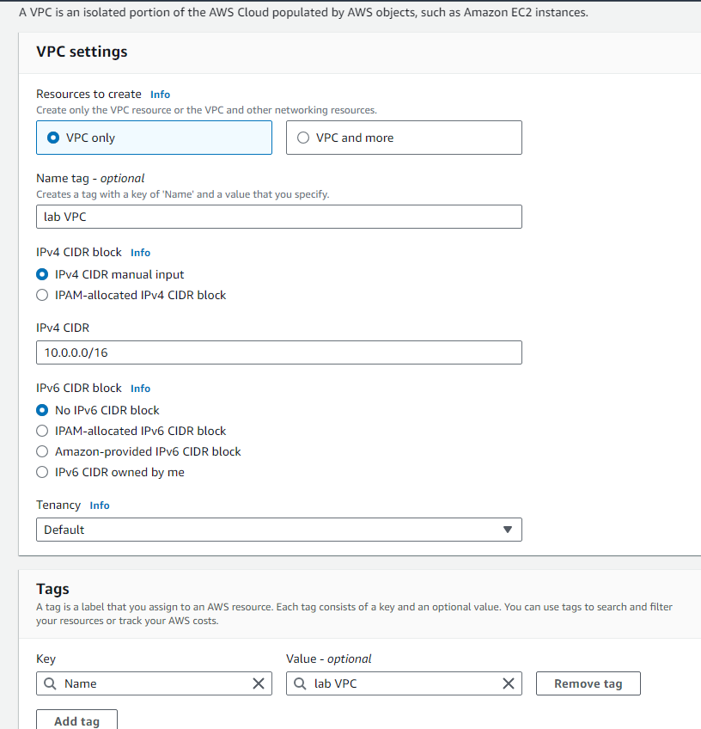

2. create 4 subnets

Public subnet 1 10.0.0.0/24 availability zone A

Private subnet 1 10.0.1.0/24 availability zone A

public subnet 2 10.0.2.0/24 availability zone B

private subnet 2 10.0.3.0/24 availability zone B

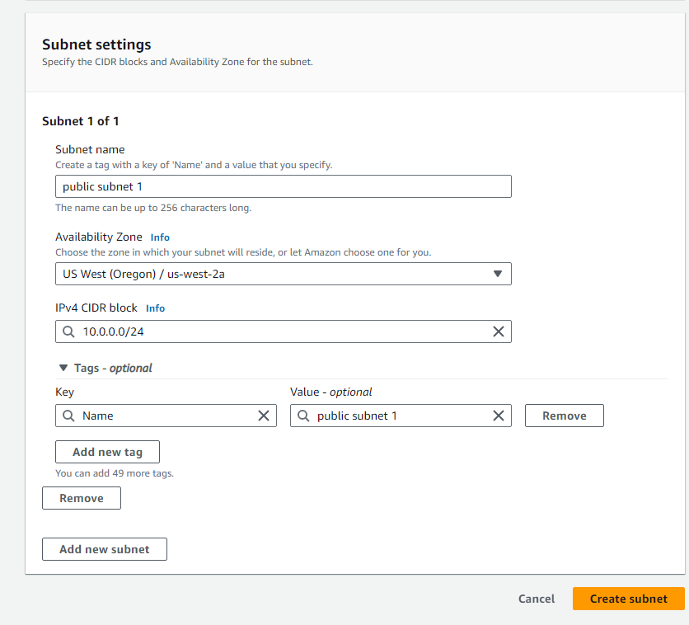

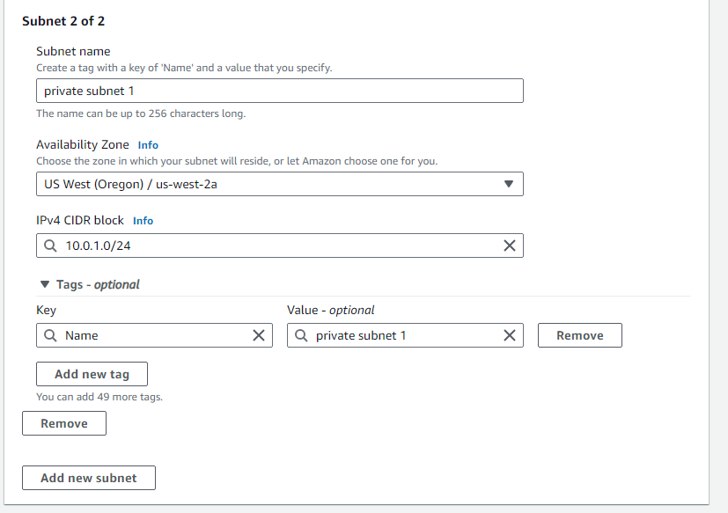

3. create NAT gateway, associate it to public subnet 1 and assign an Elastic IP

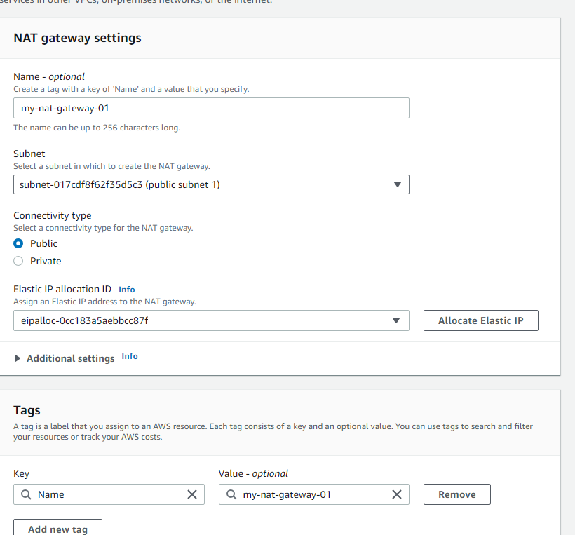

4. create Internet gateway and associate it to the VPC

4. create route tables and associate for private and public subnets

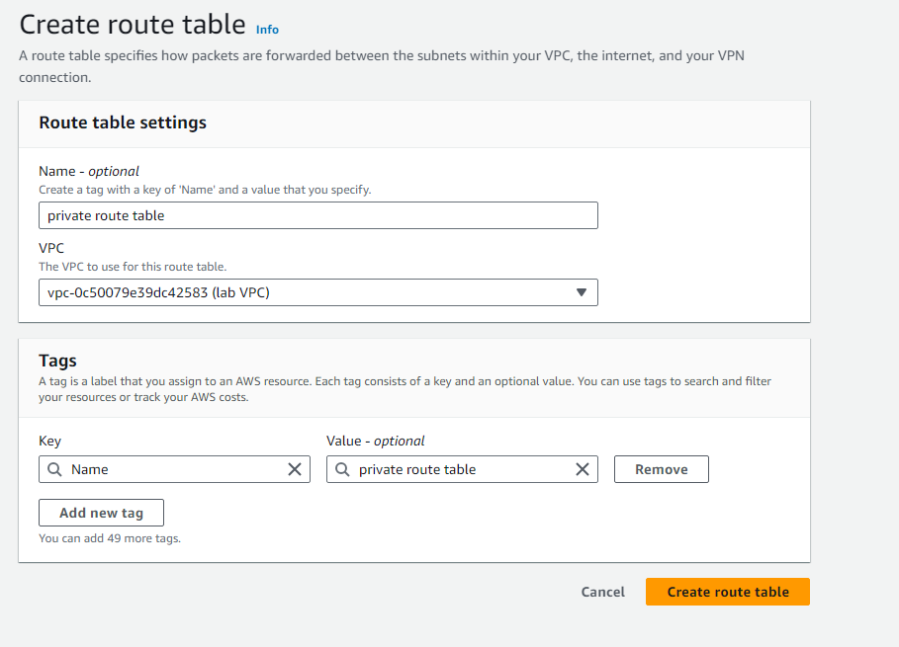

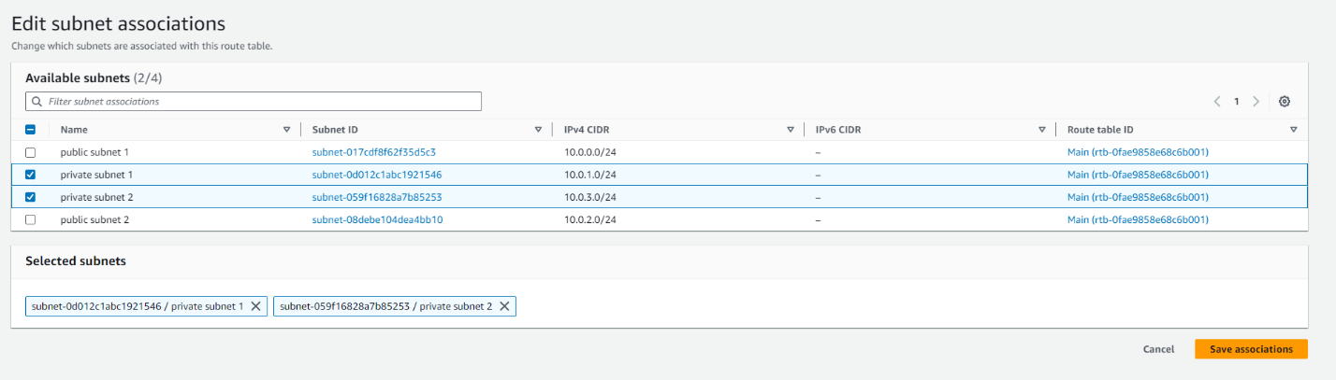

5. Add Internet gateway route to the public route table and add NAT gateway route to the private route table

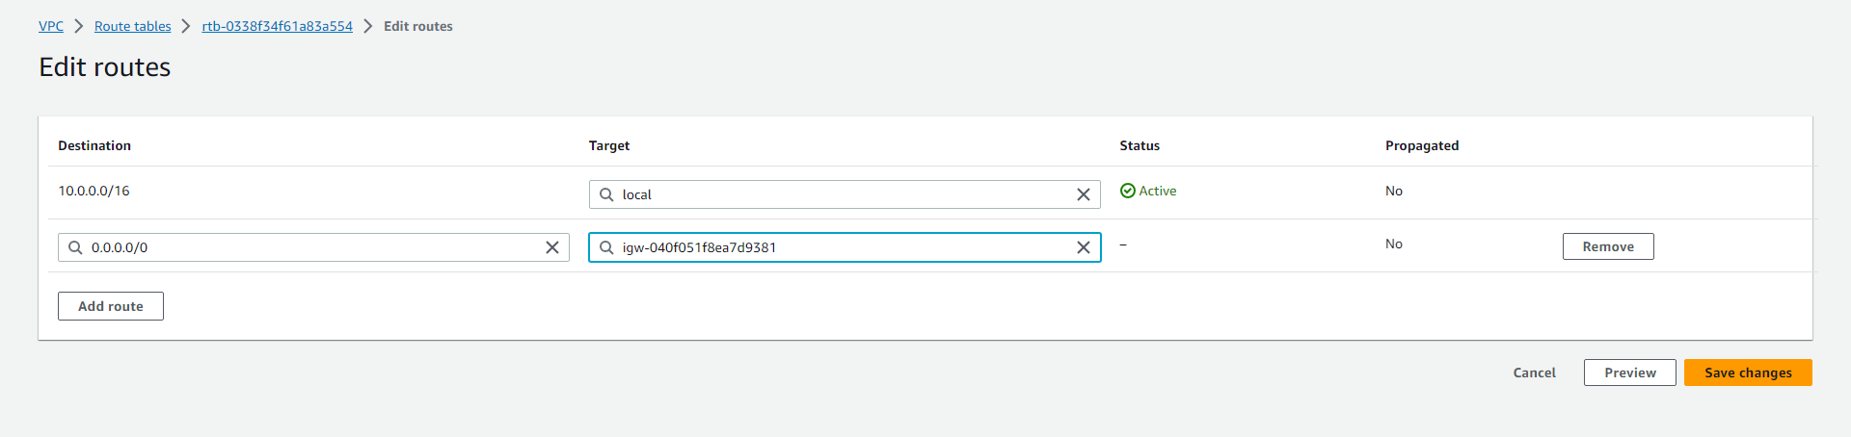

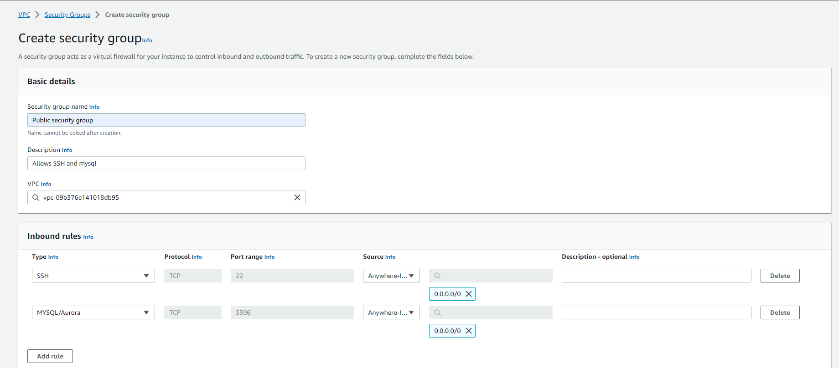6. create a security group for public subnets and permit inbound SSH and mysql (port 22, 3306)

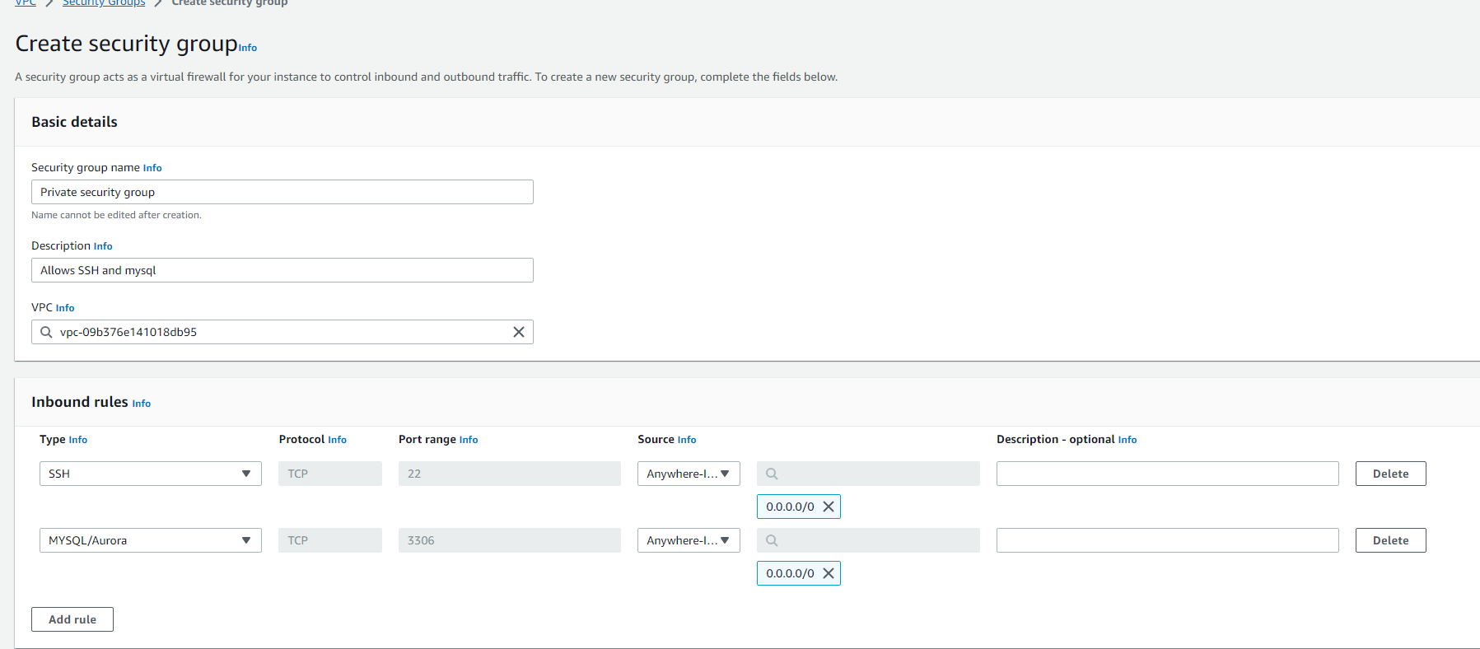7. create a security group for private subnets and permit inbound SSH and mysql (port 22, 3306)

8. create EC2 with the following network settings (public subnet 2 and public security group)

The instance is accessible from the internet (mysql client)

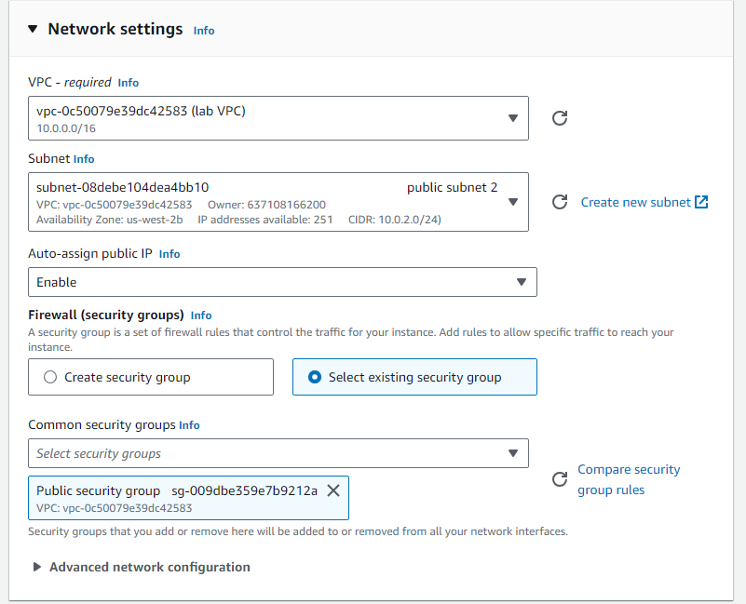

9. create EC2 with following network settings (private subnet 2 and private security group)

The instance is not accessible from the internet (mysql server)

